**ROBOTIC CAR USING ARDUINO WITH BLUETOOTH CONTROLLER**

**Mrinal Raj**

**Guided by: KRS SCOIETY**

**Kalinga Institute of Industrial Technology**

Email ID: 20151745@kiit.ac.in

**ABSTRACT**

The working is based on Arduino, L298N motor, DC motor driver, Android OS and Bluetooth module. Arduino is an opensource prototype platform. Remote control car, with an Arduino, L298N motor and Bluetooth module. Arduino and Bluetooth module. Upload the code to the Arduino using the knowledge of programming. The Arduino code simulated on software and be interface with the hardware. The device can be controlled by any smart device with android. Bluetooth Remote is an app exclusive to Android which enables you to connect your device to Mobile through a Bluetooth controller of wireless network. All the controls of the vehicle on the app on that device. It is used to follow the command by user and work with those commands.

**KEYWORDS:** Android OS, Bluetooth, Bluetooth controller, DC motors, L298N Motor Driver, Arduino Uno, Battery, PC

**INTRODUCTION**

This is an Arduino based, Bluetooth controlled RC car. It is controlled by a smart phone application.

Bluetooth controlled car is controlled by using Android mobile phone instead of any other method like

buttons, gesture etc. Here only needs to touch button in android phone to control the car in forward,

backward, left and right directions. So here android phone is used as transmitting device and Bluetooth

module placed in car is used as receiver. Android phone will transmit command using its in-built Bluetooth

to car so that it can move in the required direction like moving forward, reverse, turning left, turning right

and stop.

**Study of similar projects or technology\ literature review**

Various researches have been made by different researchers for developing this project. However, they serve a different application and have different technologies implemented. Some of those papers are mentioned below stating their technology and application.

Jorge Kazacos Winter has developed android controlled robot automation. Main aim of his project was the transfer of information wirelessly between a smartphone and the robot and developing the robot and its communication system underneath a low price and open-source philosophy. He used 3D design technique to style the structure of the robot with the facilitation of parametrical modelling software. The style, when fed to the 3D printer can print the parts of the robot in a layered manner one by one and can then use these parts to assemble the robot simply. He has used Arduino micro-controller and Wi-Fi technology in this robot.

M. Selvam in his paper has design to develop a robotic system which has a wireless camera attached to the surveillance. Bluetooth was implemented in his project for providing connection between robot and smartphone. Wireless night vision camera was used for providing the remote surveillance. The video which is recorded by camera is then transmitted to TV unit through Radio Frequency signal. He used 8051 micro controllers for the robotic unit.

Vito M Guardi has evolved the method of Bluetooth technology by developing an android app for a robot which is driven by a microcontroller. The central idea of his work is to show that one android app can be operated using totally different electronic devices. Vito M Guardi has invented a communication protocol for android smartphone and robotic platform over a Bluetooth.

Ranjith Kumar Goud and B.Santhosh Kumar have invented a pick and drop robot. They wanted it to be used for diffusing a bomb remotely with safety. For the robotic arm, they used a pair of motors and another pair as the wheels of the robot for controlling the movement. Connectivity is established using Bluetooth. The micro-controller used is LPC2148. They had also attached a wireless camera for remote surveillance. They have worked on this project mainly for industrial and military applications.

Xiao Lu, Wenjun Liu, Haixia Wang, Qia Sun have published a paper based on a project in which the smartphone is capable of IFLYTEK voice as well as handwritten input. The design is therefore robust, suitable, and practical for use and it also ensures the reliability of the full system. For connectivity between the smartphone and robot, wifi is used. Use of wifi makes it easy and absolutely convenient for controlling the robot so that it can act according to the commands.

Arpit Sharma, Reetesh Verma, Saurabh Gupta, Sukhdeep Kaur Bhatia have configured an android smartphone which can control a robot via Bluetooth technology. The phone uses motion sensors and records the gestures sent via an android mobile phone. It also has an inbuilt accelerometer and Bluetooth module for controlling the movements of a robot.

EXISTING SYSTEM:

Before they are using the remote device to be control by the robotic car. Remote controller car is a separate device to handle the car using the wired and wireless connection. Camera device are used to Fixing in the car and viewing in the system. It can use the various monitoring system in the car. It can be used also the various alerting system. Robot can used to create different kinds of purpose

**Basic concepts/ Technology used**

A Robotic car is controlled by using Android mobile phone. It is needs to touch button in android phone to control the car in forward, backward, left and right directions. So android phone is used as transmitting the device components are Arduino, DC motors, Motor Driver L293D, Battery and Bluetooth module HC-06. The Bluetooth module are placed in car is used as receiver. Bluetooth module have two different modes one is master mode and second one is slave mode. The car has two dc motors at each of its front and rear side. Front side motor is used for giving direction to car means turning left or right side. And rear side motor is used for driving the car in forward and backward direction used to handle the mobile application. Air Droid application is used to connect the mobile camera device to view in PC device of the car motions.

**PROJECT COMPONENTS**

Arduino Uno

The Arduino Uno is an open-source microcontroller board based on the Microchip

ATmega328P microcontroller and developed by Arduino.cc The board is equipped with sets of digital and

Analog input/output (I/O) pins that may be interfaced to various expansion boards (shields) and other

circuits. The board has 14 digital I/O pins (six capable of PWM output), 6 Analog I/O pins, and is

programmable with the Arduino IDE (Integrated Development Environment), via a type B USB cable. It

can be powered by the USB cable or by an external 9-volt battery, though it accepts voltages between 7

and 20 volts. The Uno board is the first in a series of USB-based Arduino boards; it and version 1.0 of the

Arduino IDE were the reference versions of Arduino, which have now evolved to newer releases. The

ATmega328 on the board comes pre-programmed with a bootloader that allows uploading new code to it

without the use of an external hardware programmer. There are many versions of Arduino boards

introduced in the market like Arduino Uno, Arduino Due, Arduino Leonardo, Arduino Mega, however,

most common versions are Arduino Uno and Arduino Mega.

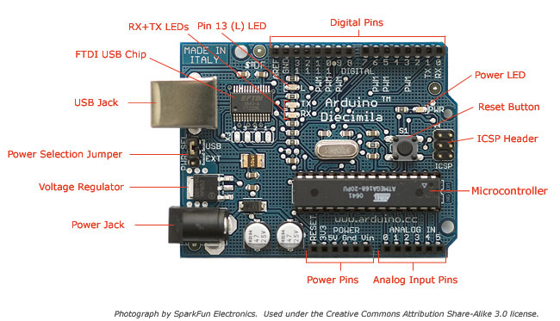

HC-05 Bluetooth Module

HC-05 is a Bluetooth module which is designed for wireless communication. This module can be used in a

master or slave configuration. It is used for many applications like wireless headset, game controllers,

wireless mouse, wireless keyboard and many more consumer applications. It has range up to <100m which

depends upon transmitter and receiver, atmosphere, geographic & urban conditions. It is IEEE 802.15.1

standardized protocol, through which one can build wireless Personal Area Network (PAN). It uses

frequency-hopping spread spectrum (FHSS) radio technology to send data over air. It uses serial

communication to communicate with devices. It communicates with microcontroller using serial port (USART).

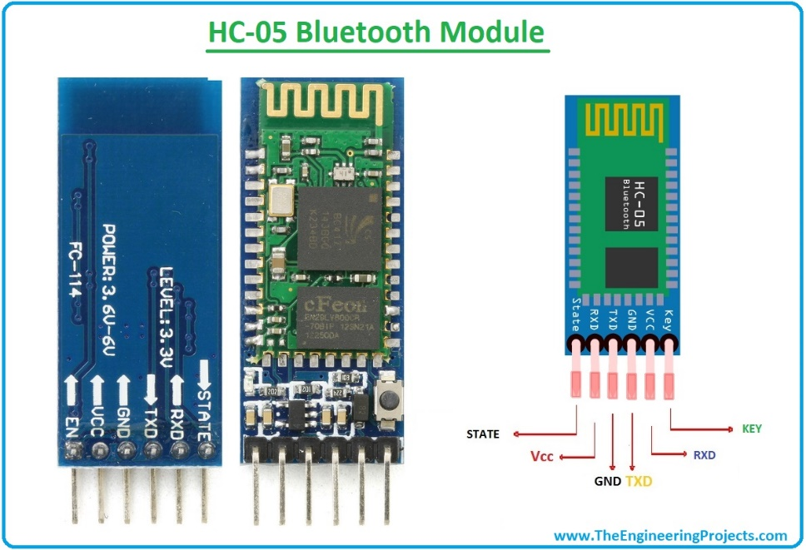

Bluetooth Communication Between Devices

First Send data from Smartphone terminal to HC-05 Bluetooth module and see this data on PC serial terminal

and vice versa. To communicate smartphone with HC-05 Bluetooth module, smartphone requires

Bluetooth terminal application for transmitting and receiving data. You can find Bluetooth terminal

applications for android and windows in respective app store. Before establishing communication between

two Bluetooth devices, 1st we need to pair HC-05 module to smartphone for communication. First, search

for new Bluetooth device from your phone. You will find Bluetooth device with ―HC-05‖ name. Second,

click on connect/pair device option; default pin for HC-05 is 1234 or 0000.In smart phone, open Bluetooth

terminal application and connect to paired device HC-05. It is simple to communicate, we just have to type

in the Bluetooth terminal application of smartphone. Characters will get sent wirelessly to Bluetooth

module HC-05.

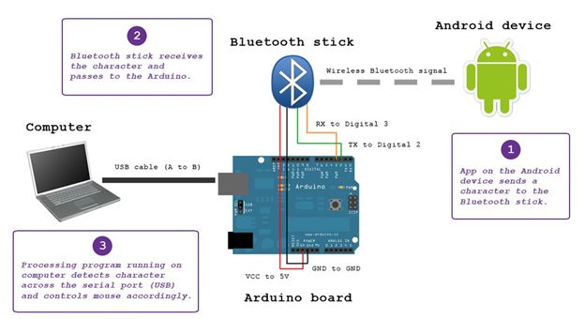

Motor Driver Module L298N

This L298N Based Motor Driver Module is a high power motor driver perfect for driving DC Motors and

Stepper Motors. It uses the popular L298 motor driver IC and has the onboard 5V regulator which it can supply

to an external circuit. It can control up to 4 DC motors, or 2 DC motors with directional and speed control

This motor driver is perfect for robotics and mechatronics projects and perfect for controlling motors from

microcontrollers, switches, relays, etc. Perfect for driving DC and Stepper motors for micro mouse, line

following robots, robot arms, etc.An H-Bridge is a circuit that can drive a current in either polarity and be

controlled by Pulse Width Modulation (PWM).Pulse Width Modulation is a means of controlling the duration of

an electronic pulse. In motors try to imagine the brush as a water wheel and electrons as the flowing droplets of

water. The voltage would be the water flowing over the wheel at a constant rate, the more water flowing the

higher the voltage. Motors are rated at certain voltages and can be damaged if the voltage is applied to heavily

or if it is dropped quickly to slow the motor down. Thus PWM. Take the water wheel analogy and think of the

water hitting it in pulses but at a constant flow. The longer the pulses the faster the wheel will turn, the shorter

the pulses, the slower the water wheel will turn. Motors will last much longer and be more reliable if controlled

through PWM.

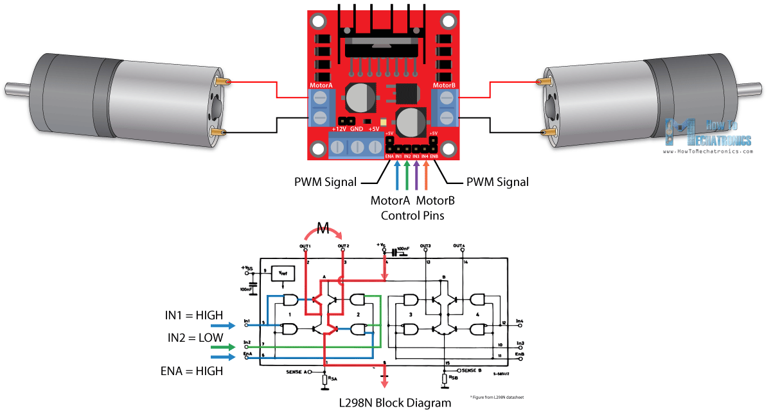

Micromrs and Grippy Wheels

Mobile wheeled or tracked robots have a minimum of two motors which are used to propel and steer the robot.

Hobbyists tend to choose skid steering (like a tank) because of its simplicity to design, incorporate and control.

A three wheeled robot‘s third (rear) wheel usually prevents the robot from falling over. Four wheeled robots

have either two or four drive motors and use skid steering. Six wheeled robots most commonly have either two,

four or six drive motors. Individuals who use an R/C car as a basis for their robot use rack and pinion steering

where one motor is connected to a drive train and the other (usually a servo motor) is used for steering.

Increasing the number of drive motors helps the robot to climb steeper inclines by increasing the torque. Adding

―idle‖ wheels (wheels not connected to a motor) often has the unfortunate consequence of removing weight

from the drive wheels resulting in slip and loss of traction. In the image below, the centre wheel, chosen

mistakenly as the driven wheel, often loses contact with the ground. The way around this is to add suspension. 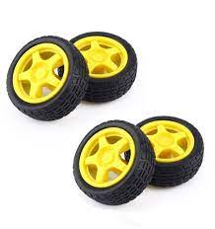

Jumper Wires

A jump wire is an electrical wire or group of them in a cable with a connector or pin at each end. Wires are used

to connect components to each other on the breadboard or other prototype, internally or with other equipment or

components, without soldering. Wire connectors could be male or female. A male connector is commonly

referred to as a plug and has a solid pin for a center conductor. A female connector is commonly referred to as a

jack and has a center conductor with a hole in it to accept the male pin.

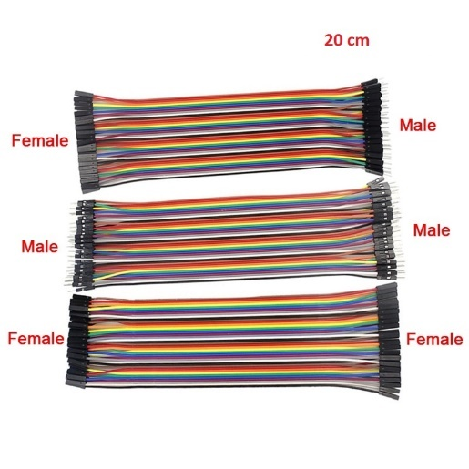

Bluetooth Controlled Car

Bluetooth controlled car is controlled by using Android mobile phone instead of any other method like buttons, gesture etc. Here only needs to touch button in android phone to control the car in forward, backward, left and right directions. So here android phone is used as transmitting device and Bluetooth module placed in car is used as receiver. Android phone will transmit command using its in-built Bluetooth to car so that it can move in the

required direction like moving forward, reverse, turning left, turning right and stop.

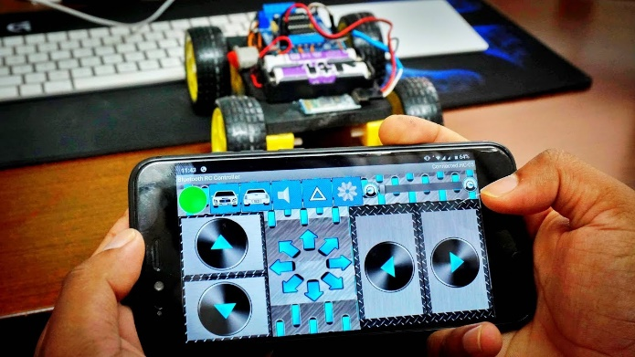

Software Description

Arduino software is used to put the instruction of whole functions of this system to the microcontroller. Here we

use programming language ‗C‘ for coding. The program for executing this project has been written in C

language. The program is burnt in the microcontroller using burner software. The program is stored in the

EEPROM of the microcontroller, which is present in the NodeMCU ESP8266. By this software we put the data

and instruction for forward, backward, left, right operation of this system. In android application when we press

a button, a corresponding signal is sent through the Bluetooth-to-Bluetooth module (HC-05) which is connected

with the NodeMCUESP8266. Similarly, an android application is been built for Wi-Fi module and when the

buttons been pressed through the application the corresponding signal is been sent through the NodeMCU

ESP8266 and the motor driver drives the wireless car. When signal data arrives the NodeMCU ESP8266 the pin

which corresponds to the particular input is set to high. Now that pin gives the output to the motor driver

section. Motor driver switches accordingly the data bit, if the data bit is low then the corresponding pin of the

motor driver doesn’t work else high bit then the corresponding pin of the motor driver is on. We have used

Arduino IDE version 1.8.1 for writing program. There are two steps of the programming. First set up section

where we define all the variables. Second loop part where the program runs continuously.

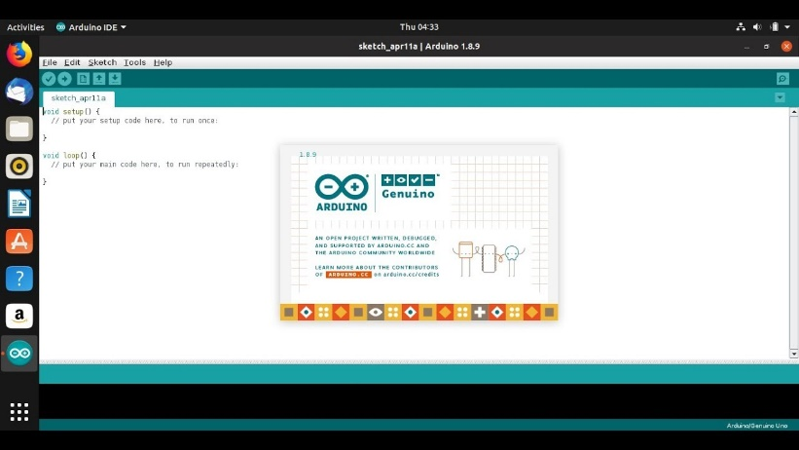

**Proposed Model / Architecture / Methodology/ Model Tool**

Take a closer look on the Wiring Diagram. We could notice the power source, four 1.5 volt batteries connected to the 12V power pin of L298 Motor Drive and ground of Motor Drive and Arduino UNO. This supplies essential power to the circuit. A total of 6 volts is being supplied to this system, where the maximum permissible amount is 12 volts. Digital wires of Arduino are connected with the input1, input2, input3 and input4 of the motor drive. Motors are connected to

the either sides of Motor Drive which are the outputs terminals. To complete the power source circuit, 5V of Motor Drive is connected to Vin power pin of Arduino UNO. Followed by this, HC05 Bluetooth Module’s Vcc is connected to 5V

pin of Arduino UNO, which supplies power to Bluetooth Module. Ground to Ground connections are also made. Transistor Transistor logic pins, Transmitter (TX) and Receiver (RX) of Arduino UNO are connected to RXD and TXD of HC05 respectively. The program is uploaded to Arduino before connecting the bluetooth module.

After all successful connections, switch on the power source. Lights at Motor Drive, Arduino UNO and HC05 would indicate the correct connection. Upon successful connection of your Bluetooth module with any android device, we

could control this device. By passing the command, for example, to move forward we pass ‘F’. This command is transmitted by our device to Bluetooth module, which in turn transmits to Arduino UNO. Arduino receives is and passes

the same to Motor Drive through its digital pins. Motor Drive will get this through their input pins and exercise them through their output pins were motor is connected.

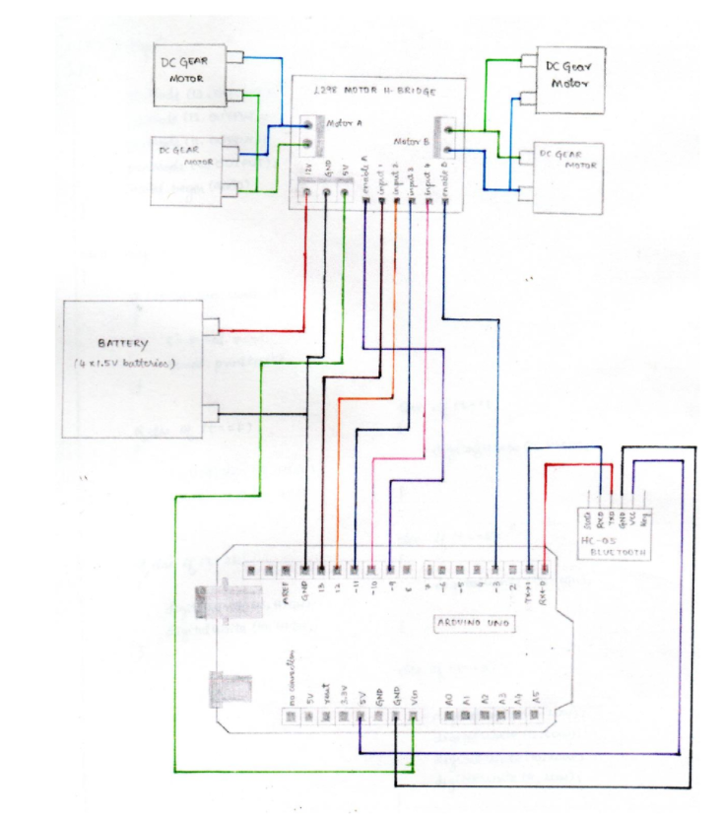

**PERFOMANCE ANALYSIS**

|  |  |  |  |
| --- | --- | --- | --- |
| Item | Quantity | Cost Each | Total |
| Arduino Uno | 1 | Rs.450 | Rs.450 |
| Hc-05 | 1 | Rs.180 | Rs.180 |
| Breadboard | 1 | Rs.50 | Rs.50 |
| Motor | 4 | Rs.40 | Rs.160 |
| Wheel | 4 | Rs.20 | Rs.80 |
| battery | 3 | Rs.50 | Rs.150 |
| wire | 1 set | Rs.50 | Rs.50 |
| chassis | 1 | Rs.20 | Rs.20 |
| L298N | 1 | Rs.50 | Rs.50 |
| Total |  |  | Rs.1090 |

**FINAL DEVICE**

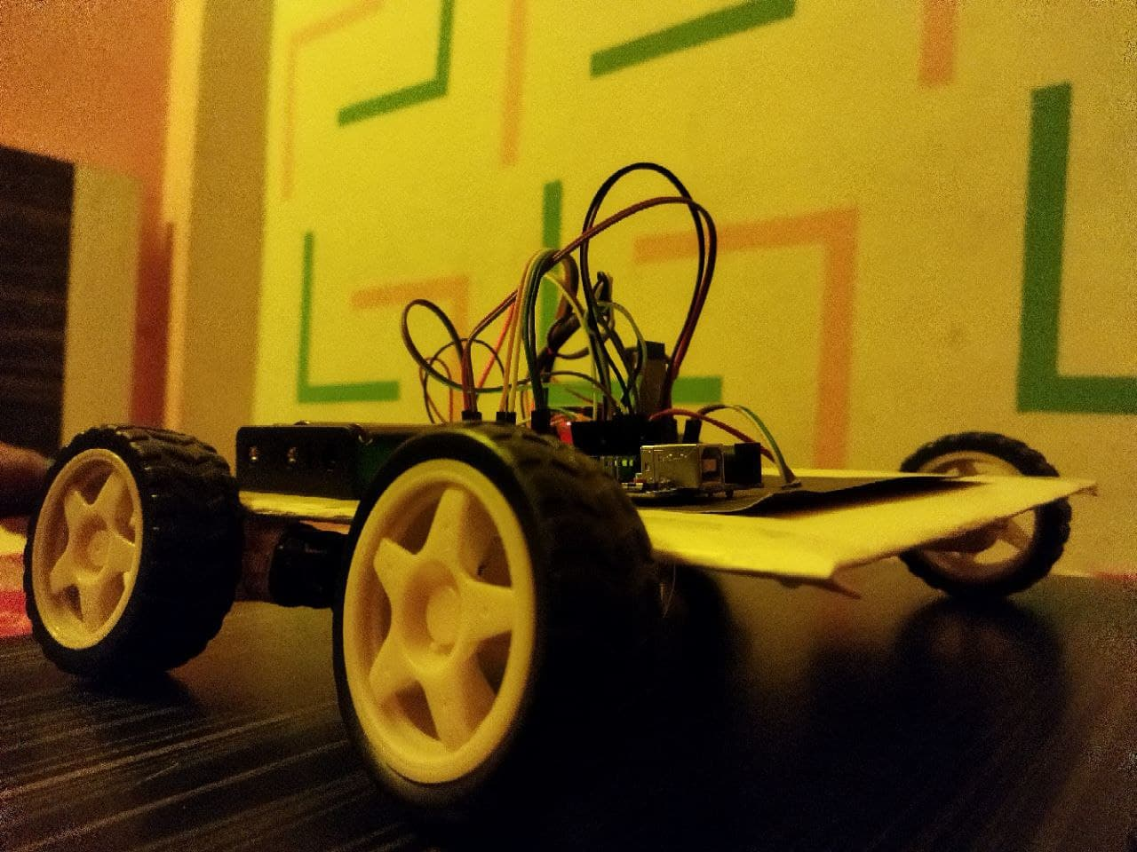 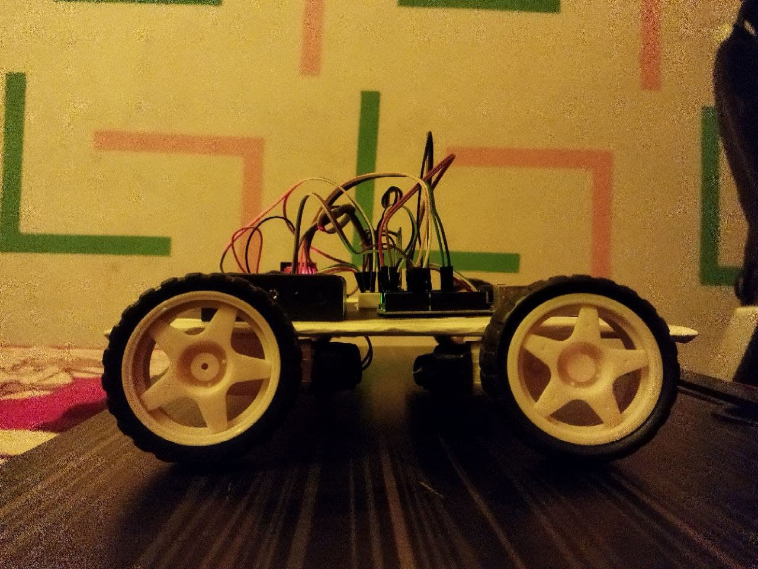

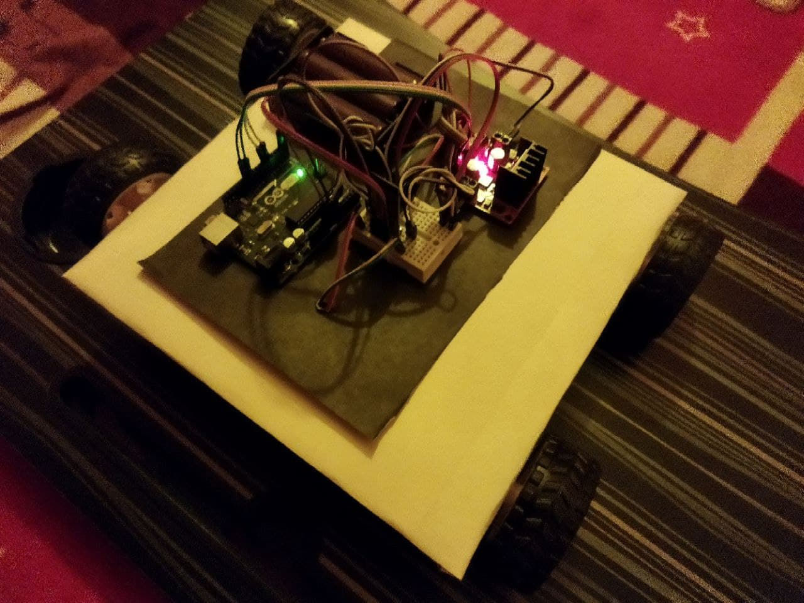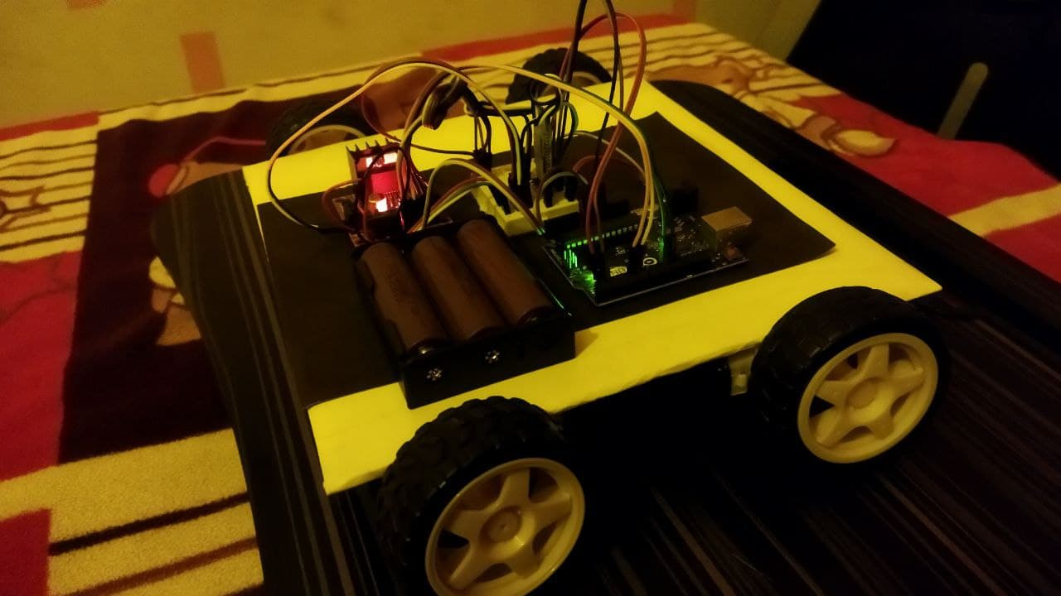

**SOCIETAL IMPACT AND FUTURE SCOPE**

Robotics, the design, construction and use of machines (robots) to perform tasks traditionally performed by humans. Robots are widely used in industries such as automobile manufacturing to perform simple and repetitive tasks, and industries that must work in environments that are harmful to humans. Many aspects of robotics involve artificial intelligence; robots can be equipped with human senses, such as vision, touch, and the ability to perceive temperature. Some are even able to make simple decisions. Current robotics research aims to design robots with a certain degree of self-sufficiency, allowing movement and decision-making in an unstructured environment.

**CONCLUSION**

To us the need of internet and the things which are internet based are very much important nowadays. IOT

or internet of things is the very important part in both computer and our daily lives. The above model

describes how the Arduino programs the car motor module and by IoT we actually rotate the wheels and

give direction to the car. IoT gives us the opportunity to work with different platforms and it helps us to

create various interesting modules to work on. We also tested the applications used to drive the car. Due to

the new concept of Wireless Controlled Car using Bluetooth, Wi-Fi and IOT, we were able to come up with

various possibilities that can take place.

**References**

In this section, add all the references of your project work. In a project paper, this section is very important. while entering the references, follow the uniform formatting for all the references listed in this section. All references in this list must be cited in appropriate places inside the paper.

[1] X. Zhang, R. Gupta, and Y. Zhang, *Precise Dynamic Slicing Algorithms*, In Proceedings 25th International Conference on Software Engineering,IEEE, pages 319-329, 2003.

[2] J. Krinke, *Context-sensitive Slicing of Concurrent Programs*, ACM SIGSOFT Software Engineering Notes, Vol-28(5), pages 178-187, 2003.

[3] G. Kiczales, J. Lamping, A. Mendhekar, C. Maeda, C. Lopes, J. M.Loingtier, and J. Irwin, *Aspect-Oriented Programming*, Springer, 1997.

[4] L. Larsen and M. J. Harrold, *Slicing Object-Oriented Software*, In Proceedingsof the 18th International Conference on Software Engineering,IEEE, pages 495-505, 1996.